VK5DJ synthesiser: a programmable crystal substitute.

The project enables connection of either an AD9850 synthesiser module or a si5351a synthesiser module to produce the ‘crystal’ frequency for either a receiver and/ or a transmitter.
The AD9850 module is an SSI device and connects to pins 24(DDSclk) , 25 (DDSfq), 26 (DSdata) of the PIC18F2480. Obviously +5V and earth must be provided as well.
The si5351a module is a I2C device and connects to pins 14 (SCL) and 15 (SDA) of the PIC18F2480.
The project expects an I2C keyboard and LCD via a MCP23017 expander chip (See diagram 2). This is the same input/output unit as used in my Mk 2 repeater controller.
On applying power a welcome screen is displayed, shortly followed by a line which describes the connected module. If the wrong module is indicated hit either the “*” (selects AD9850) or the “#” (selects si5351a) key to change the module being addressed.
Two frequencies are then written to the screen. “A” is the receive frequency,”B” is the transmit frequency. These are the true frequencies out of the modules, not the final output of the receiver or transmitter. For example if you use a TAIT UHF receiver with a 21.4MHz IF and a desired receive frequency of 442.375MHz then the calculation for the receive frequency is (442.375-21.4)/ 12 = 35.081250. In Hz this is 35081250. Don’t forget the trailing zero or you’ll end up with 3.508125MHz.
Hit the “A” key and then enter 35081250 (frequency entry must be in Hertz) and press “D” to save. As well as setting up the synthesiser this action saves the value into eedata so that next time the unit powers up it will be on 35.08125MHz. If you make a mistake hit the “C” key to cancel and the screen returns to the frequency display screen and discards any values entered.
The transmit frequency is set in a similar way but begun by pressing the “B” key.
What is the advantage of each synthesiser module?
The AD9850 module produces a sine wave at somewhat lower level (1V P/P). If the device is used to replace both the RX and the TX crystals then the output must be shared by the two units – there may be a drive problem requiring the addition of an amplifying stage. The module does have a built in filter to remove the spuria produced by interactions between the crystal frequency and the wanted output. Generally you can expect a cleaner signal from the AD9850. Whenever this module changes frequency the new frequency must be programmed in.
The si5351a module produces a much higher level square wave (5V P/P) which easily drives the receiver or transmitter at the crystal oscillator stage. Its odd harmonics are quite strong though. You’ll need to check that these are not a problem in the transmitter. A low pass filter may be necessary. Another advantage of the si5351a is that it has two (in fact 3) outputs that may be individually programmed. This project uses only outputs 0 and 1. The software in this project programs one to the receive frequency and one to the transmit frequency and then switches the appropriate output stages on or off as required.
How does the unit know when to use the TX or the RX output?
Pin 23 of the PIC is a TTL input. 0V = transmit, +5V = receiver.
It should be wired to any active low transmit port on the controller.
Diagram 1: the synthesiser controller
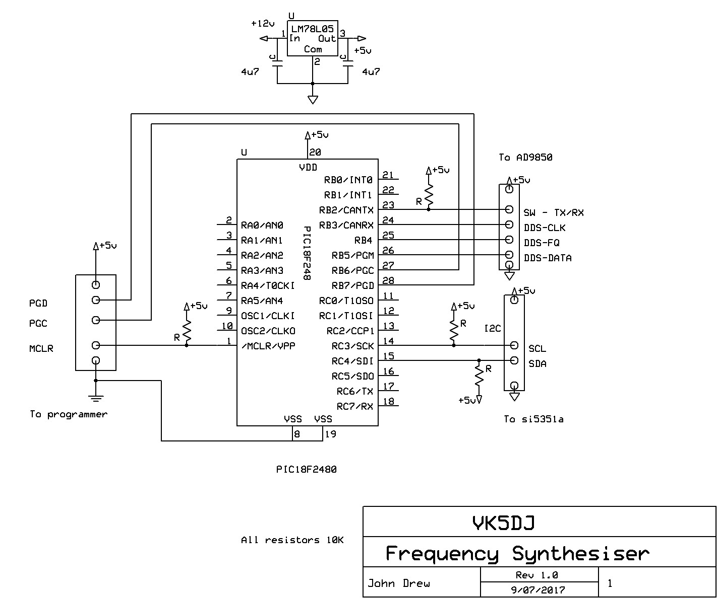

Diagram 2: Keypad/LCD
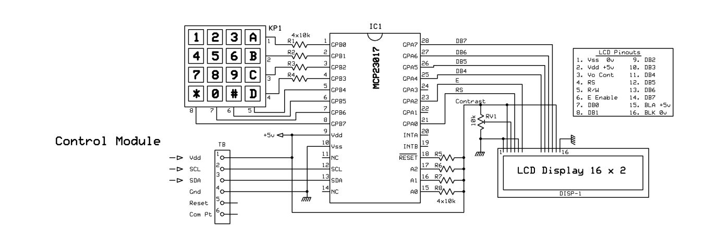
The rows and columns on the keypad shown above are provided for illustration only. I wanted the pins 1-8 on the keypad to coincide with pins 1-8 on the MCP23017 for layout reasons. In reality pin 1 of the keypad is not connected to row 1 etc.

